PIZZA SALES SQL QUERIES

1. Total_sales:

SELECT SUM(total_price) AS Total_Sales from sales

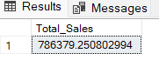

2. Avg=-order value:

SELECT SUM(total_price) / COUNT( DISTINCT order_id) AS Avg_Order_Value FROM sales

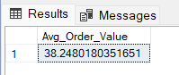

3. Total_no_of_pizza_sold:

SELECT SUM(quantity) AS Total_no_of_pizza_sold from sales

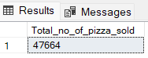

4. Total orders:

SELECT COUNT( DISTINCT order_id) AS Total_orders FROM sales

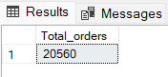

5. Avg pizza per order:

SELECT CAST(CAST(COUNT(pizza_id) AS DECIMAL(10,2)) /

CAST(COUNT(DISTINCT order_id) AS DECIMAL(10,2)) AS DECIMAL(10,2)) AS AVG_PIZZA_PER_ORDER from sales

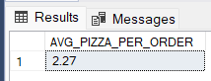

6. Daily Trend:

SELECT DATENAME(DW, order_date) as order_day, COUNT(distinct order_id) AS Total_Orders

from sales

GROUP BY DATENAME(DW, order_date)

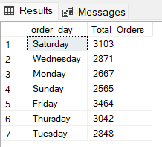

7. Hourly sales:

SELECT DATEPART(HOUR, order_time) AS order_hours, COUNT(distinct order_id) AS Total_Orders

from sales

GROUP BY DATEPART(HOUR, order_time)

ORDER BY DATEPART(HOUR, order_time)

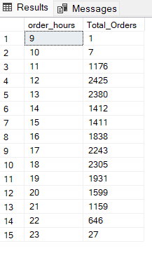

8.Pizza sales ratio:

SELECT pizza_category, CAST(SUM(total_price) AS DECIMAL(10,2)) as

total_revenue, CAST(SUM(total_price) * 100 / (SELECT SUM(total_price) from sales)

AS DECIMAL(10,2)) AS pizza_sales_ratio

FROM sales

GROUP BY pizza_category

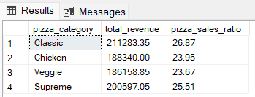

9. Pizza sales by pizza size:

SELECT pizza_size, CAST(SUM(total_price) AS DECIMAL(10,2)) as

total_revenue,

CAST(SUM(total_price) * 100 / (SELECT SUM(total_price) from sales)

AS DECIMAL(10,2)) AS pizza_sales_ratio

FROM sales

GROUP BY pizza_size

ORDER BY pizza_size

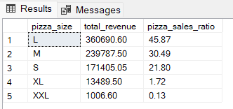

10. pizza sales by pizza category:

SELECT pizza_category, sum(quantity) as Total_pizzas_sold

from sales

GROUP BY pizza_category

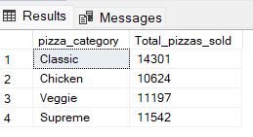

11. Top 5 pizza sales:

SELECT TOP 5 pizza_name, sum(quantity) as Total_pizza_sold

from sales

GROUP BY pizza_name

order by Total_pizza_sold DESC

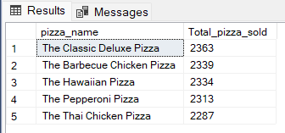

12. Bottom 5 pizza sales:

SELECT TOP 5 pizza_name, sum(quantity) as Total_pizza_sold

from sales

GROUP BY pizza_name

order by Total_pizza_sold ASC

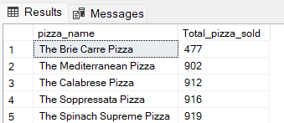

EXTRAS:

If you want to apply the Month, Quarter, Week filters to the above queries you

can use WHERE clause.

SELECT DATENAME(DW, order_date) AS order_day, COUNT(DISTINCT order_id) AS total_orders

FROM pizza_sales

WHERE MONTH(order_date) = 1

GROUP BY DATENAME(DW, order_date)

*Here MONTH(order_date) = 1 indicates that the output is for the month of January.

MONTH(order_date) = 4 indicates output for Month of April.

SELECT DATENAME(DW, order_date) AS order_day, COUNT(DISTINCT order_id) AS total_orders

FROM pizza_sales

WHERE DATEPART(QUARTER, order_date) = 1

GROUP BY DATENAME(DW, order_date)

*Here DATEPART(QUARTER, order_date) = 1 indicates that the output is for

the Quarter 1. MONTH(order_date) = 3 indicates output for Quarter 3.